SolverTable: Making sure there is a reference to Solver
Besides starting over with SolverTable, as described in the previous bullet, you should check whether SolverTable is “finding” Solver. If it can’t find the Solver.xlam file that runs Solver, then SolverTable is bound to fail and give some misleading error message. Here is how to check:
- With SolverTable loaded (i.e., assuming there is a SolverTable tab visible), press Alt+F11 to open the Visual Basic Editor (VBE) window.
- On the left, you see a list of open projects, including SolverTable. Highlight this item:
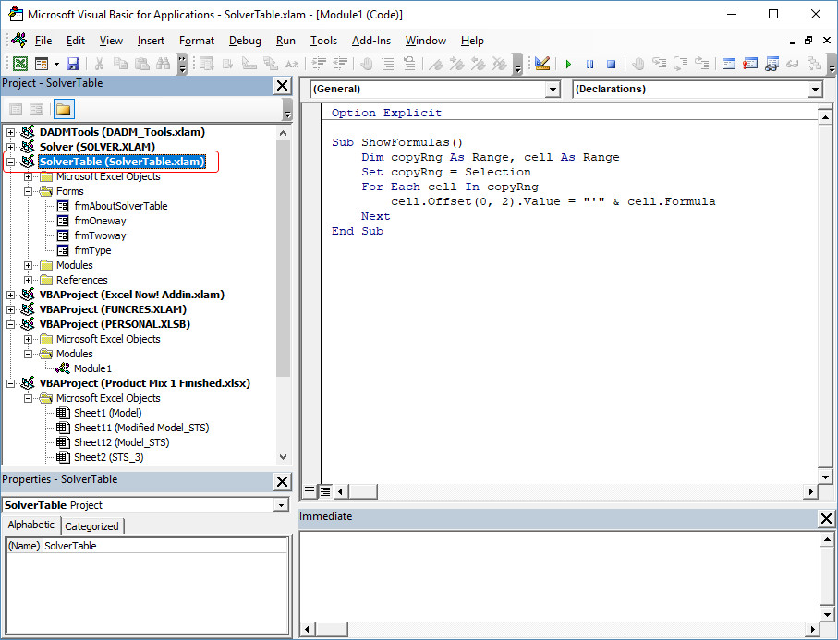
- Select References from the VBE Tools menu. This shows a list of references (the checked items) that are used by SolverTable. One of these items should be Solver.
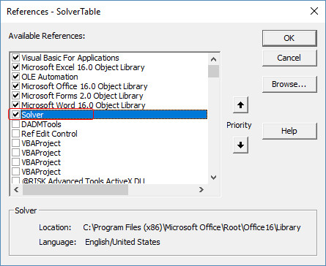
- If the Solver item is checked, you can close the VBE and continue using SolverTable, which should work fine. However, if you see a MISSING: SOLVER.XLAM item, this indicates that the Solver.xlam file SolverTable is looking for is not in the expected location on your hard drive. (This can happen for any number of reasons; it doesn’t necessarily mean that you did anything wrong.) The fix, a one-time fix, is easy. Click the Browse button and search for the Solver.xlam file. You can see in the above screenshot where it is normally located, but you might need to hunt for it. Once you find it, and the Solver item is checked as in the above screenshot, you can close the VBE. Then SolverTable should work fine.

