A Framework for
Supply Chain Restructuring

There has been much discussion recently by business leaders for the need to restructure corporate supply chains so that they are responsive to the needs of corporations in a dynamic business environment. The material presented below provides a framework for the process of supply chain restructuring. Supply chain restructuring encompasses significantly more than changes in the supply chain function, like moving to vendor managed inventories or employing electronic reverse auctions. Supply chain restructuring as used here is a fundamental alteration in a supply chain for the firm, affecting all functions and activities. The word 'restructuring' connotes many things to different people. Frequently it is used to suggest streamlining of operations, reducing redundancies, changing relationships with trading partners, etc. The framework suggested here includes this focus, but also encompasses a proactive approach to restructuring the supply chain where the appropriate response to the major forces for change is to achieve long-run capability to meet the needs of the firm.

Understanding the Restructuring Process

Restructuring of the supply chain needs to be viewed as a process of fundamental rejuvenation throughout the company. The fundamental proposition is that doing things better is necessary, but not sufficient. It is essential to do better things! Successful restructuring requires a critical understanding of

1. The forces and constraints for change - the WHY?
2. The paradigm shift required - the WHAT?
3. The implementation process - the HOW?
4. The problems awaiting solution - WHAT IS NEXT?

Forces and Constraints for Change (Why?)

Forces, both internal to the organization and external, mandate fundamental changes in business operations. Constraints, on the other hand, act to either prohibit or limit the restructuring that is undertaken. Together, the forces and constraints constitute the WHY for supply chain restructuring. From all fronts, the forces for change are expected to increase, not decrease, in intensity in the future. Companies need to understand the dynamic forces precipitating change, as well as how constraints are transformed over time, -for forces and constraints both external and internal to the organization.

- External forces and constraints stem from the environment specific to an entire industry, or to a particular firm within an industry. They include economic, social, and political forces and constraints as well as technological thrusts which impact on all players in an industry. Also included are these same forces as they uniquely impact on a particular firm with its individual set of strengths and weaknesses, both human and physical. For example, economic forces and constraints include actions by competitors, market place dictates for shorter product life cycles, world-wide competition, requirements for improved product features and prices, the demand for smaller lot sizes, the dictates imposed by the trade in consumer products and the competitive might of other firms who have undergone successful restructuring.
- Internal forces for change include any mismatch between the strengths required to compete successfully and the existing inventory of company strengths, a restatement of the overall mission and concomitant strategy for a business unit, or an initiative stimulated by some perceived need for performance improvement. To illustrate, cost structure can be a primary internal force for restructuring. Many firms have great dissatisfaction with their cost structures.
- Internal constraints include all the forms of resistance to change that include behavior, cultural, technical, financial, etc. Inertia is a major internal constraint against restructuring. Overcoming inertia -that is, surmounting the inherent mismatch between the present deployment of the enterprise resources and the issues of most importance - is a significant constraint in most companies.

The Paradigm Shift (What?)

Successful restructuring requires a well thought out set of objectives. That is, WHAT is the purpose of restructuring and how will the company be different as a result? The paradigm shift can be conceptualized as encompassing three distinct (but related) dimensions:

- Culture includes the broadest, most enduring (and most difficult to change) aspects of business. Existing culture directs and constrains restructuring efforts. Changes in culture are major shifts in the driving forces of a manufacturing company. Included are changes in strategy, mission, fundamental objectives, values held, philosophy and basic policies. Examples encompass shifting from a cost-driven company to one where high quality, time-based competition, shorter product life cycles, partnerships, etc.
- Configuration relates to both organizational designs and relationships, and to physical/geographical distributions of people, capital and equipment. Configuration change also includes transforming the definition of the basic tasks or charters of each of the supply chain activity. Inside the factory, configuration changes include regrouping of machines into cells, significant new methods of manufacturing, and major redeployments of overhead personnel. Restructuring typically results in new designs and arrangements with partners.
- Coordination refers to management and control within the business system itself. Restructuring normally requires new flows of information and materials -as well as new sets of managerial responsibilities (Oliff, Arpan and DuBois, 1989).

The foundation for restructuring rests on three fundamental resources: people, technology, and information. Restructuring the supply chain can then be defined as:

The process of changing significantly anyone or more of the three dimensions (culture, configuration, coordination), through the deployment (or redeployment) of any of the three resources (people, technology, information).

In most cases, restructuring involves all three. People perform different jobs, utilizing new technology, coordinated with new information systems.

- People deployment is at the heart of most restructuring projects, with the nature of jobs and responsibilities changing fundamentally. Examples include the elimination of managerial layers, replacement of pyramid organizations with flat or network organizations, mobilizing people to undertake new initiatives, and the continuing absorption of what has traditionally been 'staff' work into the basic supply chain infrastructure.
- Technology deployment for restructuring often involves a major shift in fundamental supply chain methods and equipment. Examples include flexible machining systems (FMS), e-procurement options, and the transfer of technology from one firm to another. Introduction and successful implementation of these major advances in technology require significant change in the culture of the company.
- Information deployment includes both the development/introduction of new management information systems (MIS) and the obsolescence of existing systems. For example, enterprise resource planning (ERP) systems mandate increase integration among key corporate activities, including order entry, manufacturing and distribution within the firm. External linkages using electronic data interchange (EDI) systems and/or the Internet have required firms to determine what business channels will need to be supported.

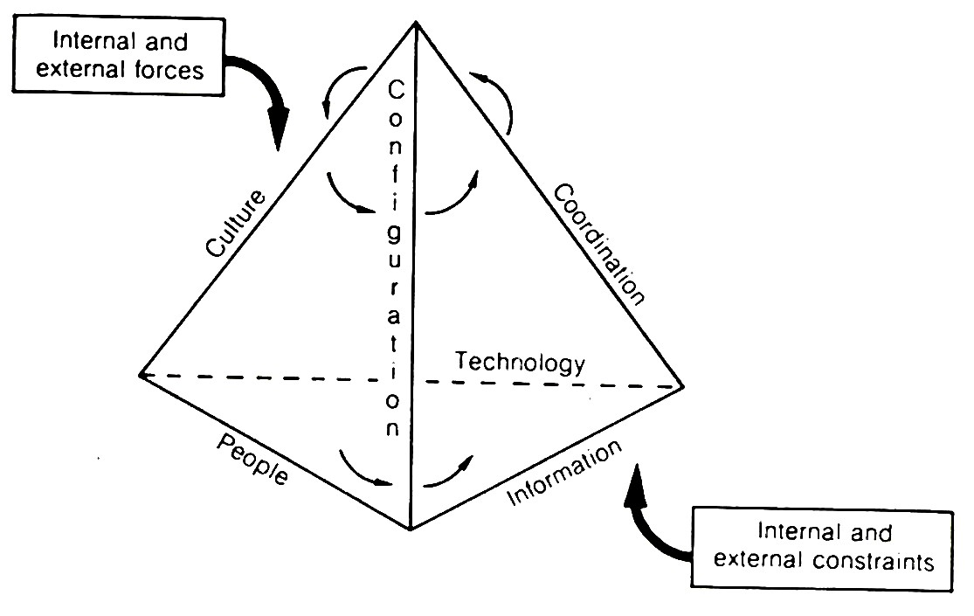
Thus, there is a very close interlinking relationship between the six elements and numerous forces, as depicted in Exhibit 1.

Exhibit 1: Restructuring Elements

The Implementation Process (How?)

Fundamental changes must be achieved in culture, configuration, and/or coordination by the redeployment of the three resources: people, technology and information. Defining the desired new configuration and the new coordination to be achieved in restructuring is more straightforward than defining the new culture that is to be achieved. But what is fundamentally more difficult is determining the set of steps required to achieve the desired result, i.e. the HOW of responding to the forces, recognizing the genuine constraints, and achieving the desired paradigm shift.

- Top-down implementation efforts are typically directed by senior management. Included are: the decision to restructure, usually based on a careful analysis of the forces and constraints; the overall objectives and approach for the restructuring, perhaps based on scenarios of various actions and competitive responses; an inclusive plan which is not simply an overall goal statement or wish list without adequate attention given to the detailed action steps required; and personal leadership to achieve the desired results and timing.
- Bottom-up implementation energies are typically required from a large number of people, in most cases the more the better. Also required is a set of key managers who will lead the implementation process. The changes required in restructuring are usually fundamental. If cultural change is necessary, the new culture can be adopted more quickly if everyone is a part of the implementation process.

Approaches to restructuring vary widely. Some firms utilize consultants essentially to serve as 'hatchet men'. Others do the entire job internally. More frequently, some middle ground is found where advice is give by consultants based on seeing other companies undertake similar responses to similar forces.

It is important not to frame the restructuring project minimally. To often this is the case -the project is defined to have the smallest possible impact on the labor force, culture, configuration and coordination. The frequent result is that it becomes necessary to undertake still another major restructuring project, with a combined impact that is far more serious for morale and culture. The approach needs to be based on the long-term competitive posture required, and the changes required to make it a reality.

Invariably, restructuring will require the learning of new values, skill and practices, and the unlearning of old beliefs. For this reason, virtually every restructuring project has to include education and training. In many successful restructuring projects, education and training has, played a major role for the company in the adoption of the new culture. The emphasis is often formally on the issues of configuration and coordination, but the bottom line is culture.

Project teams play a key role in most restructuring undertakings when formal organizational barriers are broken. Education on the fundamental forces and constraints, as well as the paradigm shift (in clearly understandable terminology) is required in order to create a bandwagon effect. It is critical that the organization both understands and believes in its definition of the forces and constraints and its paradigm shift. Too often the paradigm shift is stated as some lofty goal associated with 'getting closer to the customer', but the organization sees it as only cost-reduction and head-count reduction.

Evaluation of a restructuring program is a major challenge. The measures of effectiveness for restructuring are often not focused on what is truly important: the ability of the new business entity to compete. All too frequently, the goal is to shed X people or Y dollars of cost by the end of some period Z, or to create a better set of financial statements by next year. While recognizing the primacy of financial measures under certain conditions, the short-run orientation of many companies comes at their long-run expense.

It is difficult to tell whether the results achieved are truly successful, mediocre, or poor, or if short-term results are being achieved at the expense of long- run health. Moreover, it is necessary to take into account the continuing impact of changing forces. Frequently, restructuring requires a new system for performance measurement in the company (Dixon, Nanni and Vollmann, 1990).

A View to the Future (What is Next?)

Restructuring activities need to be clearly bounded to be tractable. What is to be included or accomplished? It also needs to have a definition of what is and is not to be included. But the WHAT IS NEXT question must also be asked. Too often restructuring is viewed as a one-time adjustment rather than a continuing process. As a particular restructuring effort is taking place, it is important always to be evaluating the next steps. To the extent that this viewpoint can be proactive, it may well help avoid the painful reactive mode of restructuring.

References

Dixon, J.R., Nanni, A.J. and Vollmann, T.E. (1990) The New Performance Challenge: Measuring Operations for World-class Competitiveness, Dow-Jones Irwin,

Oliff, M.D., Arpan, J.S. and Dubois, F.L. (1989) Global manufacturing rationalization: the design and management of international factory networks, in Management International Manufacturing (ed. K. Ferdows), North Holland, Amsterdam, 41-67.

Vollmann, T.E., Collin, R.S., Nakane, J., and Oliff, M.D. (1992) “A conceptual framework for Manufacturing restructuring”, in Manufacturing Strategy -Process and Content. Edited by Christopher A. Voss, Chapman & Hall, London

The material presented here draws heavily upon by Thomas E. Vollmann, Robert S. Collins, Jinchiro Nakane and Michael D. Oliff, in Manufacturing Strategy -Process and content. Edited by Christopher A. Voss. Published in 1992 by Chapman & Hall, London ISBN O 412436604.

