Supply Chain Introduction

WHAT IS A SUPPLY CHAIN?

A supply chain consists of all stages involved, directly or indirectly, in fulfilling a customer request. The supply chain not only includes the manufacturer and suppliers, but also transporters, warehouses, retailers, and customers themselves. Within each organization, such as a manufacturer, the supply chain includes all functions involved in filling a customer request. These functions include, but are not limited to, new product development, marketing, operations, distribution, finance, and customer service.

Consider a customer walking into a Wal-Mart store to purchase detergent. The supply chain begins with the customer and his or her need for detergent. The next stage of this supply chain is the Wal-Mart retail store that the customer visits. Wal-Mart stocks its shelves using inventory that may have been supplied from a finished goods warehouse that Wal-Mart manages or from a distributor using trucks supplied by a third party. The distributor in turn is stocked by the manufacturer (say, Procter & Gamble [P&G] in this case). The P&G manufacturing plant receives raw material from a variety of suppliers, who may themselves have been supplied by lower-tier suppliers. For example, packaging material may come from Tenneco, and Tenneco might receive raw material to manufacture the packaging from other suppliers. This supply chain is illustrated in Figure 1.
A supply chain is dynamic and involves the constant flow of information, product, and funds between different stages. Each stage of the supply chain performs different processes and interacts with other stages of the supply chain. Wal-Mart provides the product, as well as pricing and availability information, to the customer. The customer transfers funds to Wal-Mart. Wal-Mart conveys point-of-sale data as well as replenishment orders to the distribution center (DC), which transfers the replenishment order via trucks back to the store. Wal-Mart transfers funds to the distributor after the replenishment. The distributor also provides pricing information and sends delivery schedules to Wal-Mart. Similar information, material, and fund flows take place across the entire supply chain.

Figure 1: Stages of a Detergent Supply Chain
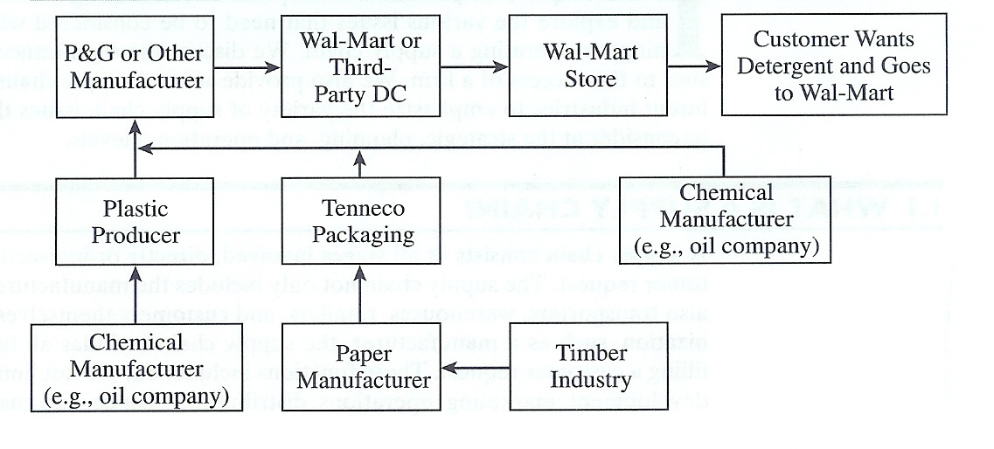

In another example, when a customer purchases on-line from Dell Computer, the supply chain includes, among others, the customer, the Web page that takes the customer's order, the Dell assembly plant, and all of Dell's suppliers and their suppliers. The Web page provides the customer with information regarding pricing, product variety, and product availability. Having made a product choice, the customer enters the order information and pays for the product. The customer may later return to the Web page to check the status of the order. Stages further up the supply chain use customer order information to fill the order. That process involves an additional flow of information, product, and funds between various stages of the supply chain.
These examples illustrate that the customer is an integral part of the supply chain. The primary purpose for the existence of any supply chain is to satisfy customer needs, in the process generating profits for itself. Supply chain activities begin with a customer order and end when a satisfied customer has paid for his or her purchase. The term supply chain conjures up images of product, or supply, moving from suppliers to manufacturers to distributors to retailers to customers along a chain. It is important to visualize information, funds, and product flows along both directions of this chain. The term may also imply that only one player is involved at each stage. In reality, a manufacturer may receive material from several suppliers and then supply several distributors. Therefore, most supply chains are actually networks. It may be more accurate to use the terms supply network or supply web to describe the structure of most supply chains.
A typical supply chain may involve a variety of stages. These supply chain stages are shown in Figure 2 and include the following:

Customers
Retailers
Wholesalers/distributors
Manufacturers
Component/raw material suppliers

Each stage in Figure 2 need not be present in a supply chain. The appropriate design of the supply chain will depend on both the customer's needs and the roles of the stages involved in filling those needs. In some cases, such as Dell, a manufacturer may fill customer orders directly. Dell builds to order, that is, a customer order initiates manufacturing at Dell. Dell does not have a retailer, wholesaler, or distributor in its supply chain. In other cases, such as the mail order company LL Bean, manufacturers do not respond to customer orders directly. LL Bean maintains an inventory of products from which it fills customer orders. Compared with the Dell supply chain, the LL Bean supply chain contains an extra stage (the retailer, LL Bean itself) between the customer and the manufacturer. In the case of a small retail store, the supply chain may also contain a wholesaler or distributor between the store and the manufacturer.

Figure 2: Supply Chain Stages
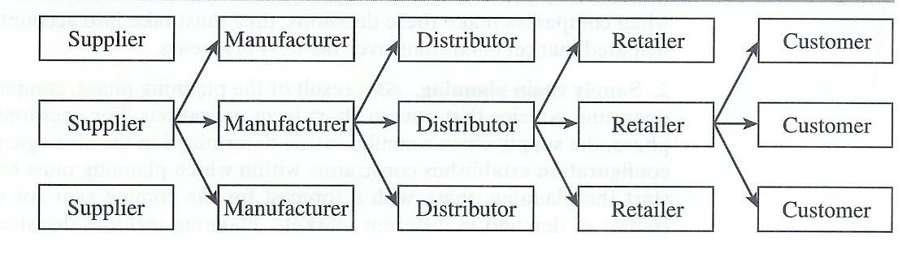

The Objective of a Supply Chain
The objective of every supply chain is to maximize the overall value generated. The value a supply chain generates is the difference between what the final product is worth to the customer and the effort the supply chain expends in filling the customer's request. For most commercial supply chains, value will be strongly correlated with supply chain profitability, the difference between the revenue generated from the customer and the overall cost across the supply chain. For example, a customer purchasing a computer from Dell pays $2,000, which represents the revenue the supply chain receives. Dell and other stages of the supply chain incur costs to convey information, produce components, store them, transport them, transfer funds, and so on. The difference between the $2,000 that the customer paid and the sum of all costs incurred by the supply chain to produce and distribute the computer represents the supply chain profitability. Supply chain profitability is the total profit to be shared across all supply chain stages. The higher the supply chain profitability, the more successful the supply chain. Supply chain success should be measured in terms of supply chain profitability and not in terms of the profits at an individual stage. (We demonstrate in subsequent chapters that a focus on profitability at individual stages may lead to a reduction in overall supply chain profits.)
We define the success of a supply chain in terms of supply chain profitability. The next logical step is to look for sources of revenue and cost. For any supply chain, there is only one source of revenue: the customer. The customer is the only real point of positive cash flow in a supply chain. In the Wal-Mart example, the customer purchasing detergent is the only one providing positive cash flow for the supply chain. All other cash flows are simply fund exchanges that occur within the supply chain, given that different stages have different owners. When Wal-Mart pays its supplier, it is taking a portion of the funds the customer provides and passing that money on to the supplier. This cash transfer adds to the supply chain's costs. All flows of information, product, or funds generate costs within the supply chain. Therefore, the appropriate management of these flows is a key to supply chain success. Supply chain management involves the management of flows between and among stages in a supply chain to maximize total profitability.
In the next section, we categorize supply chain decision phases based on their duration.

DECISION PHASES IN A SUPPLY CHAIN

Successful supply chain management requires several decisions relating to the flow of information, product, and funds. These decisions fall into three categories or phases, depending on the frequency of each decision and the time frame over which a decision phase has an impact:
1. Supply chain strategy or design. During this phase, a company decides how to structure the supply chain. It decides what the chain's configuration will be and what processes each stage will perform. Decisions made during this phase are also referred to as strategic supply chain decisions. Strategic decisions made by companies include the location and capacities of production and warehousing facilities, products to be manufactured or stored at various locations, modes of transportation to be made available along different shipping legs, and type of information system to be utilized. A firm must ensure that the supply chain configuration supports its strategic objectives during this phase. Dell's decisions regarding the location and capacity of its manufacturing facilities, warehouses, and supply sources are all supply chain design or strategic decisions. Supply chain design decisions are typically made for the long term (a matter of years) and are very expensive to alter on short notice. Consequently, when companies make these decisions, they must take into account uncertainty in anticipated market conditions over the next few years.

2. Supply chain planning. As a result of the planning phase, companies define a set of operating policies that govern short-term operations. For decisions made during this phase, the supply chain's configuration determined in the strategic phase is fixed. This configuration establishes constraints within which planning must be done. Companies start the planning phase with a forecast for the coming year (or a comparable time frame) of demand in different markets. Planning includes decisions regarding which markets will be supplied from which locations, the planned buildup of inventories, the subcontracting of manufacturing, the replenishment and inventory policies to be followed, the policies that will be enacted regarding backup locations in case of a stockout, and the timing and size of marketing promotions. Dell's decisions regarding the markets a given production facility will supply and target production quantities at different locations are classified as planning decisions. Planning establishes parameters within which a supply chain will function over a specified period of time. In the planning phase, companies must include uncertainty in demand, exchange rates, and competition over this time horizon in their decisions. Given a shorter time horizon and better forecasts than the design phase, companies in the planning phase try to incorporate whatever flexibility may have been built into the supply chain in the design phase and exploit it to optimize performance in the shorter term.
3. Supply chain operation. The time horizon here is weekly or daily, and during this phase companies make decisions regarding individual customer orders. At the operational level, supply chain configuration is considered fixed and planning policies already defined. The goal of supply chain operations is to implement the operating policies in the best possible manner. During this phase, firms allocate individual orders to inventory or production, set a date that an order is to be filled, generate pick lists at a warehouse, allocate an order to a particular shipping mode and shipment, set delivery schedules of trucks, and place replenishment orders. Because operational decisions are being made in the short term (minutes, hours, or days), there is often less uncertainty about demand information. The goal during the operation phase is to exploit the reduction of uncertainty and optimize performance within the constraints established by the configuration and planning policies.

The design, planning, and operation of a supply chain have a strong impact on overall profitability and success. Consider Dell Computer. In 1993, Dell performed poorly, and its stock price dropped sharply. This led Dell management to focus on improving the design, planning, and operation of the supply chain, resulting in significantly improved performance. Both profitability and the stock price subsequently have soared due to this increase in performance.
In later chapters, we develop concepts and present methodologies that can be used at each of the three decision phases described previously. Most of our discussion addresses the supply chain design and planning phases.

Push/Pull View of Supply Chain Processes

All processes in a supply chain fall into one of two categories, depending on the timing of their execution relative to customer demand. In pull processes, execution is initiated in response to a customer order. Push processes are those that are executed in anticipation of customer orders. At the time of execution of a pull process, demand is known with certainty. At the time of execution of a push process, demand is not known and must be forecast. Pull processes may also be referred to as reactive processes because they react to customer demand. Push processes may also be referred to as speculative processes because they respond to speculated (or forecast) rather than actual demand. The push/pull boundary in a supply chain separates push processes from pull processes. At Dell, for example, the beginning of personal computers (PC) assembly represents the push/pull boundary. All processes before PC assembly are push processes, and all processes after and including assembly are initiated in response to a customer order and are thus pull processes.
A push/pull view of the supply chain is very useful when considering strategic decisions relating to supply chain design. This view forces a more global consideration of supply chain processes as they relate to a customer order. Such a view may, for instance, result in responsibility for certain processes being passed on to a different stage of the supply chain if making this transfer allows a push process to become a pull process.

Let us consider two distinct supply chains that we have discussed and relate them to the push/pull and the cycle views. One supply chain is a mail order company like LL Bean that receives customer orders through its telemarketing center or Web site. The other is a build-to-order computer manufacturer like Dell.
LL Bean executes all processes in the customer order cycle after the customer arrives. All processes that are part of the customer order cycle are thus pull processes. Order fulfillment takes place from product inventory that is built up in anticipation of customer orders. The goal of the replenishment cycle is to ensure product availability when a customer order arrives. All processes in the replenishment cycle are performed in anticipation of demand and are thus push processes. The same holds true for processes in the manufacturing and procurement cycle. In fact, raw material like fabric is often purchased six to nine months before customer demand is expected. Manufacturing itself begins three to six months before the point of sale. All processes in the manufacturing and procurement cycle are thus push processes. The processes in the LL Bean supply chain break up into pull and push processes, as shown in Figure 3.

Figure 3: Push/Pull Process for LL Bean
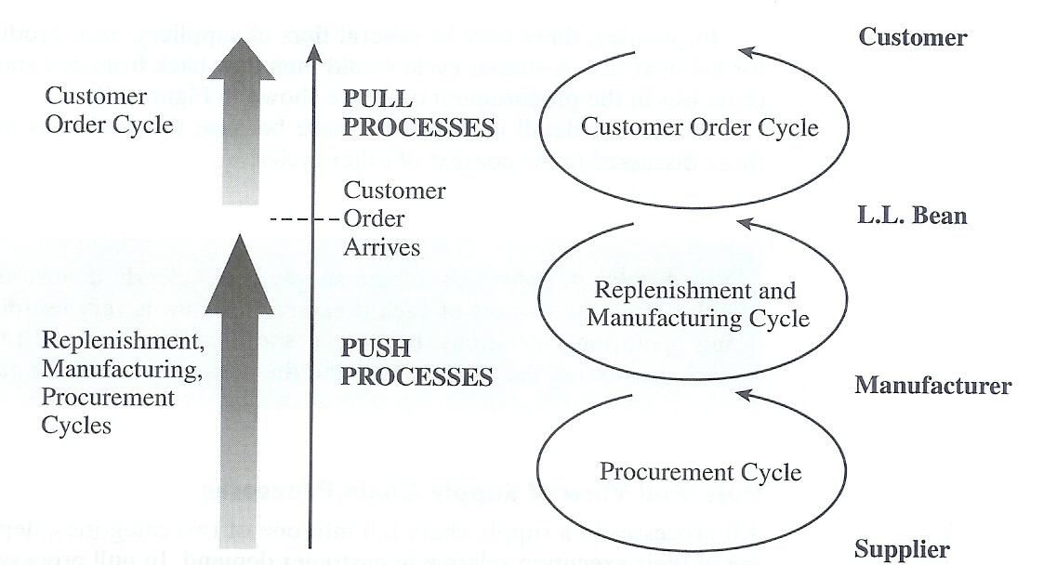

The situation is different for a build-to-order computer manufacturer like Dell. Dell does not sell through a reseller or distributor but rather directly to the consumer. Demand is not filled from finished-product inventory but from production. The arrival of a customer order triggers production in final assembly. The manufacturing cycle is thus part of the customer order fulfillment process in the customer order cycle. There are effectively only two cycles in the Dell supply chain: (1) a customer order and manufacturing cycle and (2) a procurement cycle, as shown in Figure 4.

Figure 4: Cycles in Dell Supply Chain
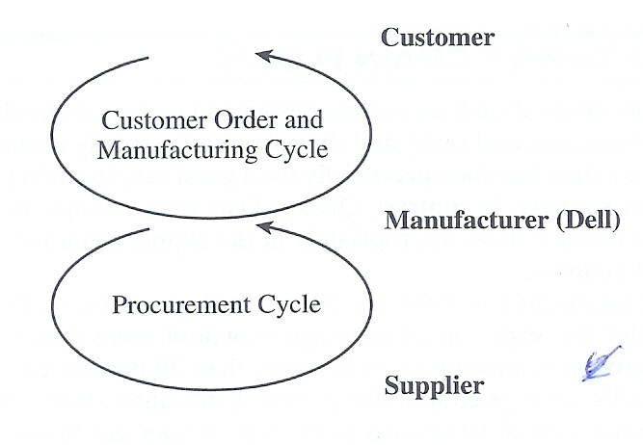

All processes in the customer order and manufacturing cycle at Dell are thus classified as pull processes because they are initiated by customer arrival. Dell, however, does not place component orders in response to a customer order. Inventory is replenished in anticipation of customer demand. All processes in the procurement cycle for Dell are thus classified as push processes because they are a response to a forecast. The processes in the Dell supply chain break up into pull and push processes, as shown in Figure 5.
One clear distinction between the two supply chains discussed previously is that the Dell supply chain has fewer stages and more pull processes than the LL Bean supply chain. As we indicate in the following chapters, this fact has a significant impact on supply chain performance.

Figure 5: Push/Pull Process for Dell Supply Chain
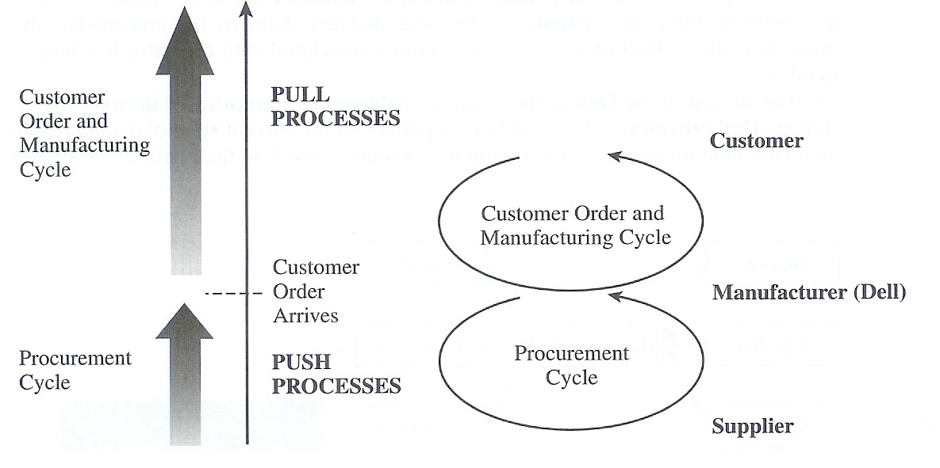

THE IMPORTANCE OF SUPPLY CHAIN FLOWS

There is a close connection between the design and management of supply chain flows (product, information, and cash) and the success of a supply chain. Dell Computer is an example of a firm that has successfully used good supply chain practices to support its competitive strategy. In contrast, Quaker Oats is an example in which the inability to design and manage flows appropriately in the supply chain led to the failure of its acquisition of Snapple.
Dell was established in 1984. By 1998, it had grown into a $12 billion company. Since 1993, Dell has experienced earnings growth of more than 65 percent per year. Its earnings growth is anticipated to be more than 30 percent per year over the next five years. Dell's stock price has also grown significantly since 1993. Dell has attributed a significant part of its success to the way it manages flows-product, information, and cash-within its supply chain.
Dell's basic supply chain model is direct sales to customers. As distributors and retailers are bypassed, the Dell supply chain has only three stages-customers, manufacturer, and suppliers, as shown in Figure 6.

Figure 6: Dell Supply Chain Stages
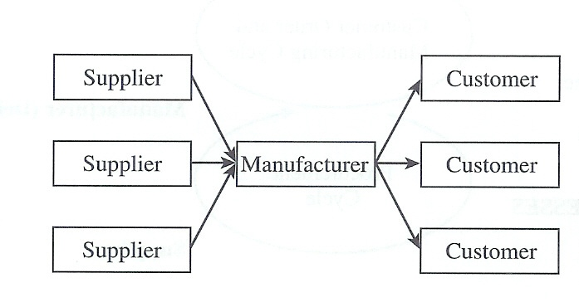

Because Dell is in direct contact with its customers, it has been able to finely segment them and analyze the needs and profitability of each segment. Close contact with its customers and an understanding of customers' needs also allows Dell to develop better forecasts. To further improve the match between supply and demand, Dell makes an active effort to steer customers in real time, on the phone or via the Internet, toward PC configurations that can be built given the components available.
On the operational side, inventory turns is a key performance measure that Dell watches very closely. Each computer chip carries a date code to indicate how old a part is. Dell carries only about 10 days' worth of inventory; in contrast, the competition, selling through retailers, has been carrying in the vicinity of 80 to 100 days. If Intel introduces a new chip, the low level of inventory allows Dell to go to market with a PC containing the chip faster than the competition. If prices suddenly drop, as they did in the early part of 1998, Dell has less inventory that loses value relative to its competitors. For some products, such as monitors manufactured by Sony, Dell maintains no inventory. The transportation company simply picks up the appropriate number of computers from Dell's Austin plant and monitors from Sony's factory in Mexico, matches them by customer order, and delivers them to the customers. This procedure allows Dell to save time and money associated with the extra handling of monitors.
The success of the Dell supply chain is facilitated by sophisticated information exchange. Dell provides real-time data to suppliers on the current state of demand. Suppliers are able to access their components' inventory levels at the factories along with daily production requirements. Dell has created customized Web pages so that its major suppliers can view demand forecasts and other customer-sensitive information, thus helping suppliers to get a better idea of customer demand and better match their production schedules to that of Dell. The company has production concentrated in five manufacturing centers: Austin, Texas; Brazil; China; Ireland; and Malaysia. Because demand at each location is relatively large and stable, suppliers are able to replenish component inventories regularly, allowing Dell to maintain low levels of component inventories. In some cases, Dell carries only hours of component inventory at its factory.
Dell's low levels of inventory also help ensure that defects are not introduced into a large quantity of product. When a new product is launched, supplier engineers are stationed right in the plant. If a customer calls in with a problem, production is stopped and design flaws are fixed in real time. As there is no finished product in inventory, the amount of defective merchandise produced is minimized.
Dell also outsources service and support to third-party providers. To ensure a high quality of service, Dell coordinates the delivery of the parts the customer requires with the arrival of the service person. Once again, a coordinated flow of information and material minimizes the cost necessary to provide a high level of service.
Dell also manages its cash flows very effectively. By tracking and managing receivables and payables very closely, it is able to collect cash from its customers, on average, five days before it has to pay its suppliers.
Clearly, Dell's supply chain design and appropriate management of product, information, and cash flows playa key role in the company's success. This approach has positioned Dell very well within the PC industry. Given that good product performance is common in the PC industry, the competitive battlefield is now focused on service delivery and supply chain efficiency.
Quaker Oats, with its acquisition of Snapple, provides an example in which failure to design and manage supply chain flows led to financial failure. Quaker owns Gatorade, the top-selling brand in the sports drink segment. In December 1994, Quaker purchased Snapple at a cost of $1.7 billion. Snapple sold all-natural drinks. At that time, Gatorade was very strong in the south and the southwest of the United States, while Snapple was strong in the northeast and on the west coast.
Quaker announced that it hoped to exploit synergies between the two distribution systems to gain efficiencies, but the company was unable to remedy several problems that prevented it from achieving these synergies. Gatorade was manufactured in plants owned by Quaker, while Snapple was produced under contract by outside plants. Gatorade sold significant amounts through supermarkets and grocery stores, while Snapple sold primarily through restaurants and independent retailers. Over the two years following its acquisition of Snapple, Quaker was unable to gain much synergy between the two distribution systems. In trying to merge two disparate distribution systems, Quaker helped neither and may have hurt both. Just 28 months later, Quaker sold Snapple to Triarc Companies for about $300 million, about 20 percent of the purchase price. The inability to achieve synergies between the two supply chains was a significant reason for the failure of Snapple at Quaker.

EXAMPLES OF SUPPLY CHAINS

In this section, we consider several supply chains and raise questions that would have to be answered during the design, planning, and operations phases of these supply chains. In later chapters, we discuss concepts and present methodologies that can be used to answer these questions.

Example: Micron Electronics Inc.- A Direct Sales Manufacturer
Micron Electronics Inc. is a manufacturer of PCs that sells directly to customers who place orders either through the telephone or the Internet. Micron has one assembly facility, located in Idaho. It also has a subcontractor that is able to assemble the most popular models. A typical customer order comes in via the Internet or a toll-free number. Depending on the type of order (individual or corporate; high volume or low-volume item), it is allocated either to the Idaho facility or the subcontractor. Large corporate orders, for example, are handled out of Idaho. Micron carries almost no finished-goods inventory and assembles PCs in response to customer orders.
A typical order may include a monitor and a printer in addition to the Pc. Micron does not manufacture peripherals such as monitors and printers. They are stored in Memphis at a depot that Federal Express (FedEx) operates for Micron with some peripherals also held at the Idaho facility. Thus, the order taker must allocate product to the peripheral order from items in the depot. For an individual order, FedEx transports the assembled PC (either from Idaho or the subcontractor) to Memphis, where it is merged with the peripherals from the depot. Another possibility is for FedEx to do the merge at a station close to the customer site. For example, an order from Chicago can be merged in Chicago itself. The merged order is then delivered to the customer. To facilitate this in-transit merge, Micron shares detailed electronic information with the FedEx warehouse as PCs ship out of Idaho. Customers can track the status of their orders after they have placed them.
For large corporate orders within the United States, Micron does not use FedEx. It uses less-than-truckload (LTL) companies to move the product. Currently, these orders are filled using peripherals that are stocked in Idaho.
Micron outsources both PC components and peripherals throughout the world. The company uses airfreight as well as ocean transport to move product to the United States, and then a combination of truck and rail to move it into warehouses.
The following supply chain design, planning, and operational decisions have a bearing on the performance of the Micron supply chain:
1. Why has assembly of certain PCs been outsourced? What characterizes PCs or orders that have been outsourced?
2. Why does Micron have only one manufacturing site?
3. Why are individual orders shipped using FedEx and large corporate orders shipped using LTL?
4. Why are individual orders merged in transit rather than at the assembly site itself?
5. How much inventory of components and finished products is maintained? What inventory policies are used to manage replenishment?
6. Why are some components brought by airfreight and others by ocean? On what basis is the transportation mode selected for a shipment?
Answers to these questions determine the appropriateness of the design, planning, and operation of the supply chain. Manufacturers that sell both direct and through resellers, like Hewlett Packard and Compaq, will need a different supply chain design to best support their strategy. How should they design and manage their supply chains?

Example: W.W. Grainger and McMaster-Carr- Maintenance, Repair, and Operations Suppliers
W.W. Grainger and McMaster-Carr sell maintenance, repair, and operations (MRO) products. Both companies have catalogs, as well as Web pages through which orders can be placed. Grainger also has several hundred stores throughout the United States. Customers can walk into a store, call in an order, or place it via the Web. Grainger orders are either shipped to the customer or picked up by the customer at one of the stores. McMaster-Carr, in contrast, ships all orders. Grainger has several DCs that both replenish stores and fill customer orders. McMaster has DCs from which all orders are filled. Neither McMaster nor Grainger manufacture any product. They serve the role of a distributor or retailer. Their success is thus largely linked to their supply chain management ability.
Both firms offer several hundred thousand products to their customers. Each firm stocks about 200,000 products; the rest are obtained from the supplier as needed. Both firms face the following strategic and operational issues:
1. How many DCs should there be, and where should they be located?
2. How should product stocking be managed at the DCs? Should all DCs carry all products?
3. What products should be carried in inventory and what products should be left with the supplier?
4. What products should Grainger carry at a store?
5. How should markets be allocated to DCs in terms of order fulfillment? What should be done if an order cannot be completely filled from a DC? Should there be specified backup locations? How should they be selected?
6. How should replenishment of inventory be managed at the various stocking locations?
7. How should Web orders be handled relative to the existing business? Is it better to integrate the Web business with the existing business or to set up separate distribution?
8. What transportation modes should be used for order fulfillment and stock replenishment?
Example: Toyota - A Global Auto Manufacturer
Toyota Motor Corporation is Japan's number-one auto manufacturer and has experienced significant growth in global sales over the last two decades of the 20th century. A key issue facing Toyota is the design of its global production and distribution network. Part of Toyota's global strategy is to open factories in every major market it serves. Toyota must decide what the production capability of each of the factories will be, as this has a significant impact on the desired distribution system. At one extreme, each plant is equipped only for local production. At the other extreme, each plant is capable of supplying every market. Prior to 1996, Toyota used specialized local factories for each market. After the Asian financial crisis in 1996/1997, Toyota focused on redesigning its plants so that they could be shifted quickly to exporting to markets that remain strong. Toyota calls this strategy "global complementation."
Whether to be global or local is also an issue for Toyota's parts plants: Should they be designed for local consumption, or should there be few parts plants globally that supply multiple assembly plants?
For any global manufacturer like Toyota, several questions arise regarding the
configuration and capability of the supply chain:
1. Where should the plants be located, and what degree of flexibility should be built into each? What capacity should each plant have?
2. Should plants be able to produce for all markets or only specific contingency markets?
3. How should markets be allocated to plants, and how frequently should this allocation be revised?
4. What kind of flexibility should be built into the distribution system?
5. How should this flexible investment be valued?
6. What actions may be taken during product design to facilitate this flexibility?

Example: Amazon.com - An E-Business
Amazon.com sells books, music, and other items over the Internet. It is one of the largest e-commerce firms, with a market capitalization of more than $20 billion. This figure is particularly impressive, considering that the firm was incorporated in 1994. The firm had annual sales of $1.6 billion in 1999, but it has yet to turn a profit.
Amazon.com is based in Seattle and started by filling all orders using books purchased from a distributor in response to customer orders. This practice differs from that of a traditional bookstore those purchases directly from publishers and stocks books in anticipation of customer orders. Today, Amazon.com has seven warehouses where it holds inventory. Amazon.com stocks best-selling books, though it still gets other titles from distributors. It uses the U.S. Postal Service and other package carriers like United Parcel Service (UPS) and FedEx to send books to customers. Given that Amazon.com has not yet turned a profit, there are several questions to be answered about the use of the e-commerce channel for retailing in general and selling books in particular.
Traditional booksellers like Borders and Barnes and Noble have also started selling using the Internet channel. Barnes and Noble has set up BarnesandNoble.com as a separate company. The two supply chains, however, share common warehousing and transportation to some extent, a change from Barnes and Noble's original supply chain strategy when BarnesandNoble.com was not visible in any Barnes and Noble bookstore.
Several questions arise regarding how Amazon.com is structured and how traditional booksellers have responded:
1. Why is Amazon.com building more warehouses as it grows? How many warehouses should it have, and where should they be located?
2. What advantages does selling books via the Internet provide over a traditional bookstore? Are there any disadvantages to selling via the Internet?
3. Why does Amazon.com stock best-sellers while buying other titles from distributors?
4. Does the Internet channel provide greater value to a bookseller like Borders with retail outlets or to an e-business like Amazon.com?
5. Should traditional booksellers like Barnes and Noble integrate e-commerce into their current supply chain or manage it as a separate supply chain?
6. For what products does the e-commerce channel offer the greatest advantage? What characterizes these products?

Fisher, Marshall L. "What Is the Right Supply Chain for Your Product?" Harvard Business Review (March-April 1997),83-93.

Fuller, J. B., J. O'Conner, and R. Rawlinson. "Tailored Logistics: The Next Advantage." Harvard Business Review (May-June 1993), 87-98.

Quinn, Francis J. "Reengineering the Supply Chain: An Interview with Michael Hammer." Supply Chain Management Review (Spring 1999), 20-26.

Robeson, James F., and William C. Copacino (eds.). TheLogistics Handbook. New York: The Free Press, 1994.

Shapiro, Roy D. "Get Leverage from Logistics." Harvard Business Review (May-June 1984), 119-127.

